Soc 756
Problem Set 5

1. The following data describe the U.S. population in 1997. The life table values come from a female life table with a radix of 100,000.
Age Group | Femalesª | All births | Female births | _{n}L_{x} | l_{x}
10 | 9,315,000 | 10,121 | 4,899 | 495,678 | 99,174
15 | 9,302,000 | 483,220 | 236,207 | 494,913 | 99,083
20 | 8,591,000 | 942,048 | 460,534 | 493,741 | 98,868
25 | 9,446,000 | 1,069,436 | 523,179 | 492,428 | 98,624
30 | 10,447,000 | 886,798 | 432,638 | 490,757 | 98,336
35 | 11,373,000 | 409,710 | 200,533 | 488,395 | 97,945
40 | 10,800,000 | 76,084 | 37,288 | 484,977 | 97,381
45 | 9,409,000 | 3,333 | 1,617 | 479,969 | 96,561
Total Population by Sex |  | Number
Males |  | 130,783,000
Females |  | 137,001,000
ª Population as of July 1, 1997.

A. What was the Crude Birth Rate in the United States in 1997?
B. What was the General Fertility Rate in the United States in 1997? By what factor does the GFR differ from the CBR and why?
C. Calculate and graph the age-specific fertility rates in the United States in 1997.
D. Calculate and interpret the Total Fertility Rate in the United States in 1997.
E. Calculate and interpret the Gross Reproduction Rate (GRR) in the United States in 1997. Assume that the sex ratio of births is invariant to the age of the mother and equal to 1.05.
F. Calculate and interpret the Net Reproduction Rate (NRR) in the United States in 1997. Make the same assumption as in 2.E.
G. How close is your answer in F to the NRR you would approximate by NRR = p(A_{m}) x GRR? What is the value of this approximation?
The mean age of the maternity schedule can be obtained as follows:

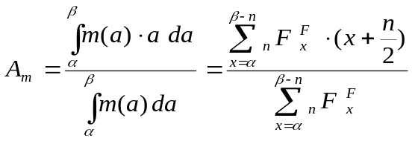
(eq. 5.21 of the textbook)

You may assume that l(x) is linear within the intervals (follows the form l(x)=a+bx) to interpolate the value of l(A_{m}) if needed.

2. In hypothetical population Tau, the fecund period is 250 months, the fecundability of all women is 0.2 at all ages during the fecund period, the average anovulatory period after pregnancy is 13 months, the duration of aborted pregnancies is 2 months and the post-abortion anovulatory period is 3 months.

Suppose that eleven possible contraceptive techniques are being considered for a cohort of women. The effectiveness of these techniques range from 0.45 to 0.95 in increments of 0.05.

Using equation 1, graph the expected TFR by contraceptive effectiveness, both in the absence of abortion and in the presence of a 1:1 ratio of abortions to live births. Graph the percent decrease in the TFR implied by the presence of abortion by contraceptive effectiveness.
Interpret both graphs.

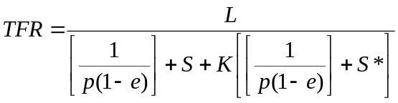
(1)

Recall that in equation 5.18 pg. 113 in Preston et al. for the NRR, _{n}L_{x}^{F} refers to person years lived among women among a cohort of l₀ women. That is, both the person-years lived and the radix refer to life table quantities for women.

